**WEBAPI 01**

**Aim:**

Create a .Net core web application with API template. Use the option to create controller with Read Write permissions. Notice the ValuesController creation with Action methods corresponding to the Action verbs.

**ValueControllers.cs:**

using Microsoft.AspNetCore.Mvc;

using System.Collections.Generic;

namespace FirstWebApiDemo.Controllers

{

    [Route("api/[controller]")]

    [ApiController]

    public class ValuesController : ControllerBase

    {

        private static readonly List<string> Data = new() { "Item1", "Item2" };

        [HttpGet]

        public IActionResult GetAll() => Ok(Data);

        [HttpGet("{id:int}")]

        public IActionResult GetById(int id)

        {

            if (id < 0 || id >= Data.Count) return NotFound();

            return Ok(Data[id]);

        }

        [HttpPost]

        public IActionResult Create([FromBody] string value)

        {

            if (string.IsNullOrWhiteSpace(value)) return BadRequest("value required");

            Data.Add(value);

            return CreatedAtAction(nameof(GetById), new { id = Data.Count - 1 }, value);

        }

        [HttpPut("{id:int}")]

        public IActionResult Update(int id, [FromBody] string value)

        {

            if (id < 0 || id >= Data.Count) return NotFound();

            Data[id] = value;

            return NoContent();

        }

        [HttpDelete("{id:int}")]

        public IActionResult Delete(int id)

        {

            if (id < 0 || id >= Data.Count) return NotFound();

            Data.RemoveAt(id);

            return NoContent();

        }

    }

**Program.cs:**

var builder = WebApplication.CreateBuilder(args);

builder.Services.AddControllers();

builder.Services.AddEndpointsApiExplorer();

builder.Services.AddSwaggerGen();

var app = builder.Build();

if (app.Environment.IsDevelopment())

{

    app.UseSwagger();

    app.UseSwaggerUI();

}

app.UseHttpsRedirection();

app.UseAuthorization();

app.MapControllers();

app.Run();

**Output:**

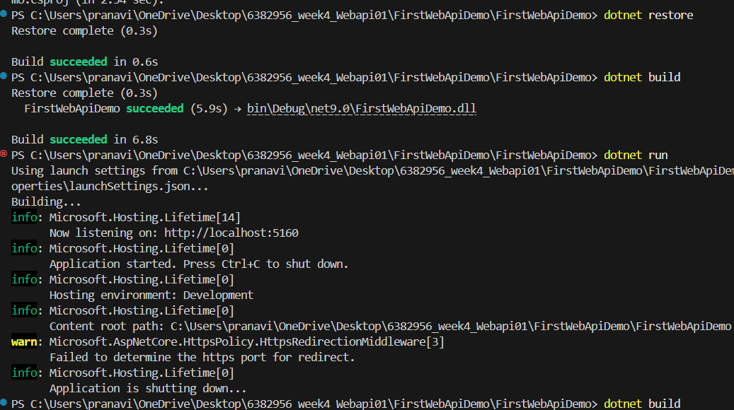

**Output 1:**

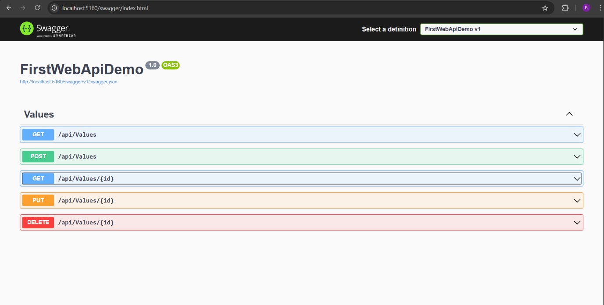

**Output 2:**

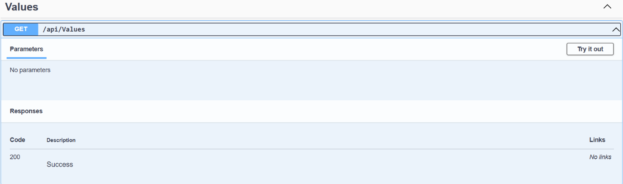

**Output 3:**

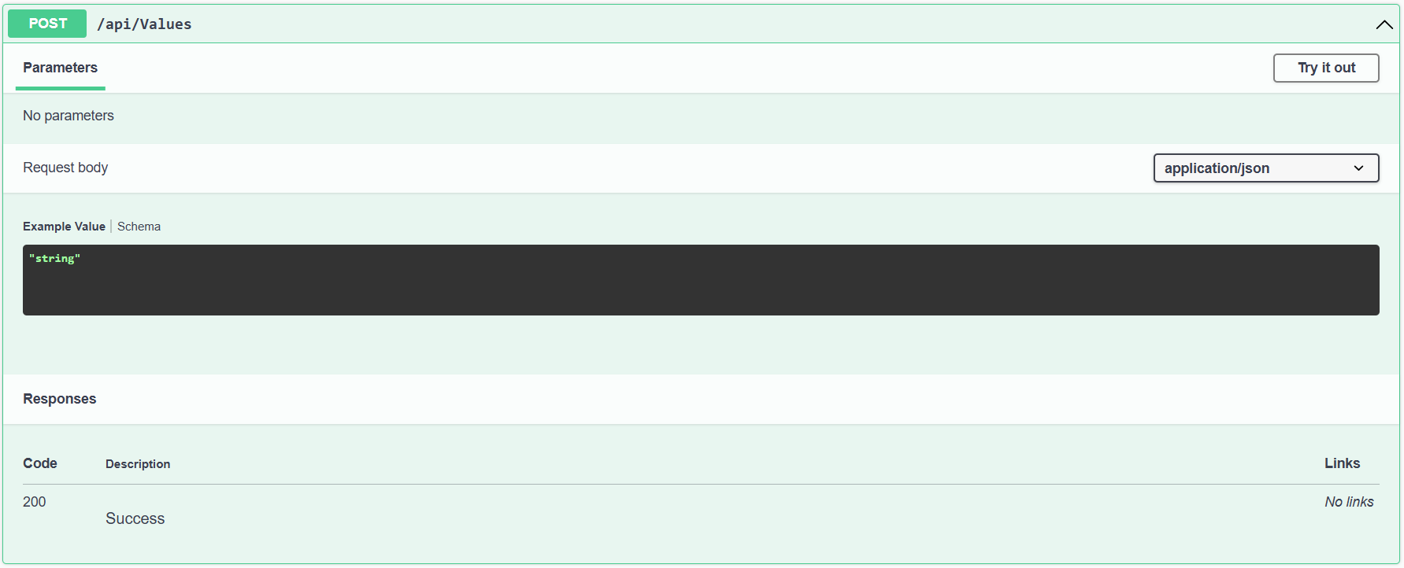

**Output 4:**



**Output 5:**

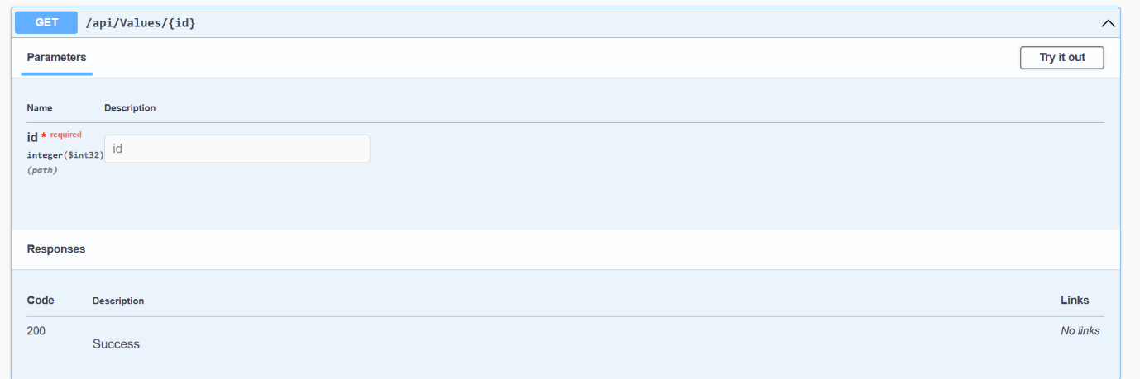

**Output 6:**

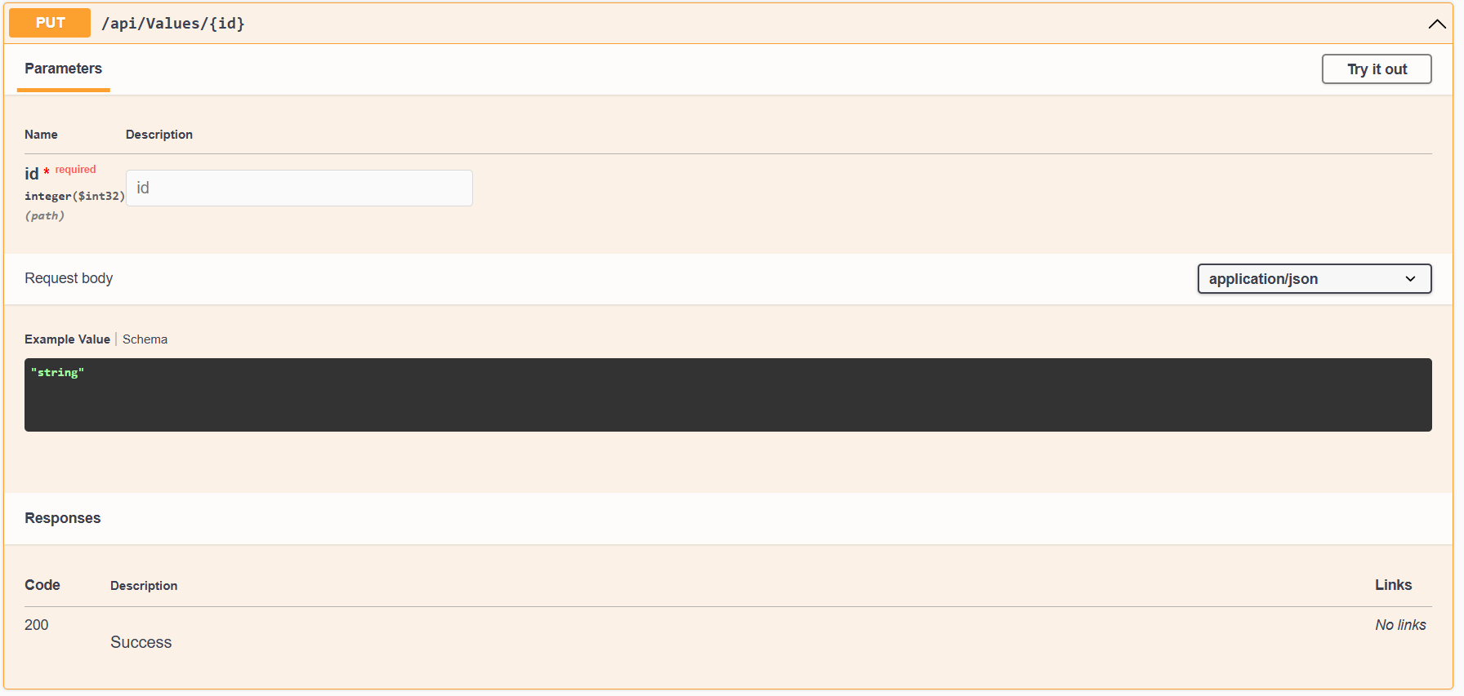

**Output 7:**

